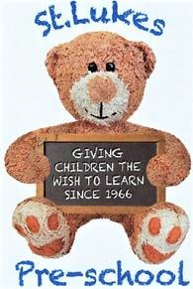 | St Lukes Pre-School  Term Dates – 2024-2025
Thursday 5th September 2024 – Autumn term begins
15th October – school photos
Monday 21st to Friday 25th October – half term break
Wednesday 4th December – Dress rehearsal (am children)
Saturday 7th December – Breakfast with Santa
Wednesday 11th December – Christmas Play (am children)
Thursday 12th December – Christmas party and end of term.
Friday 13th December – staff only

Monday 6th January 2025– Spring term begins – PM children (Tuesday 7th ALL)
Monday 17th to Friday 21st February – Half term break
Friday 4th April – Spring term ends

Tuesday 22nd April 2025– Summer term begins – PM children only (Wednesday 23rd ALL)
Monday 5th May – May Bank Holiday – pre-school closed
Monday 26th May – Friday 30th May – half term break
June – Sports Day (am children) – date tbc
Thursday 10th July – Pre-school trip to Kent Life (leavers only)
Wednesday 16th July – Teddy Bear’s Picnic and end of term
Thursday 17th & Friday 18th July – stocktake – staff only

